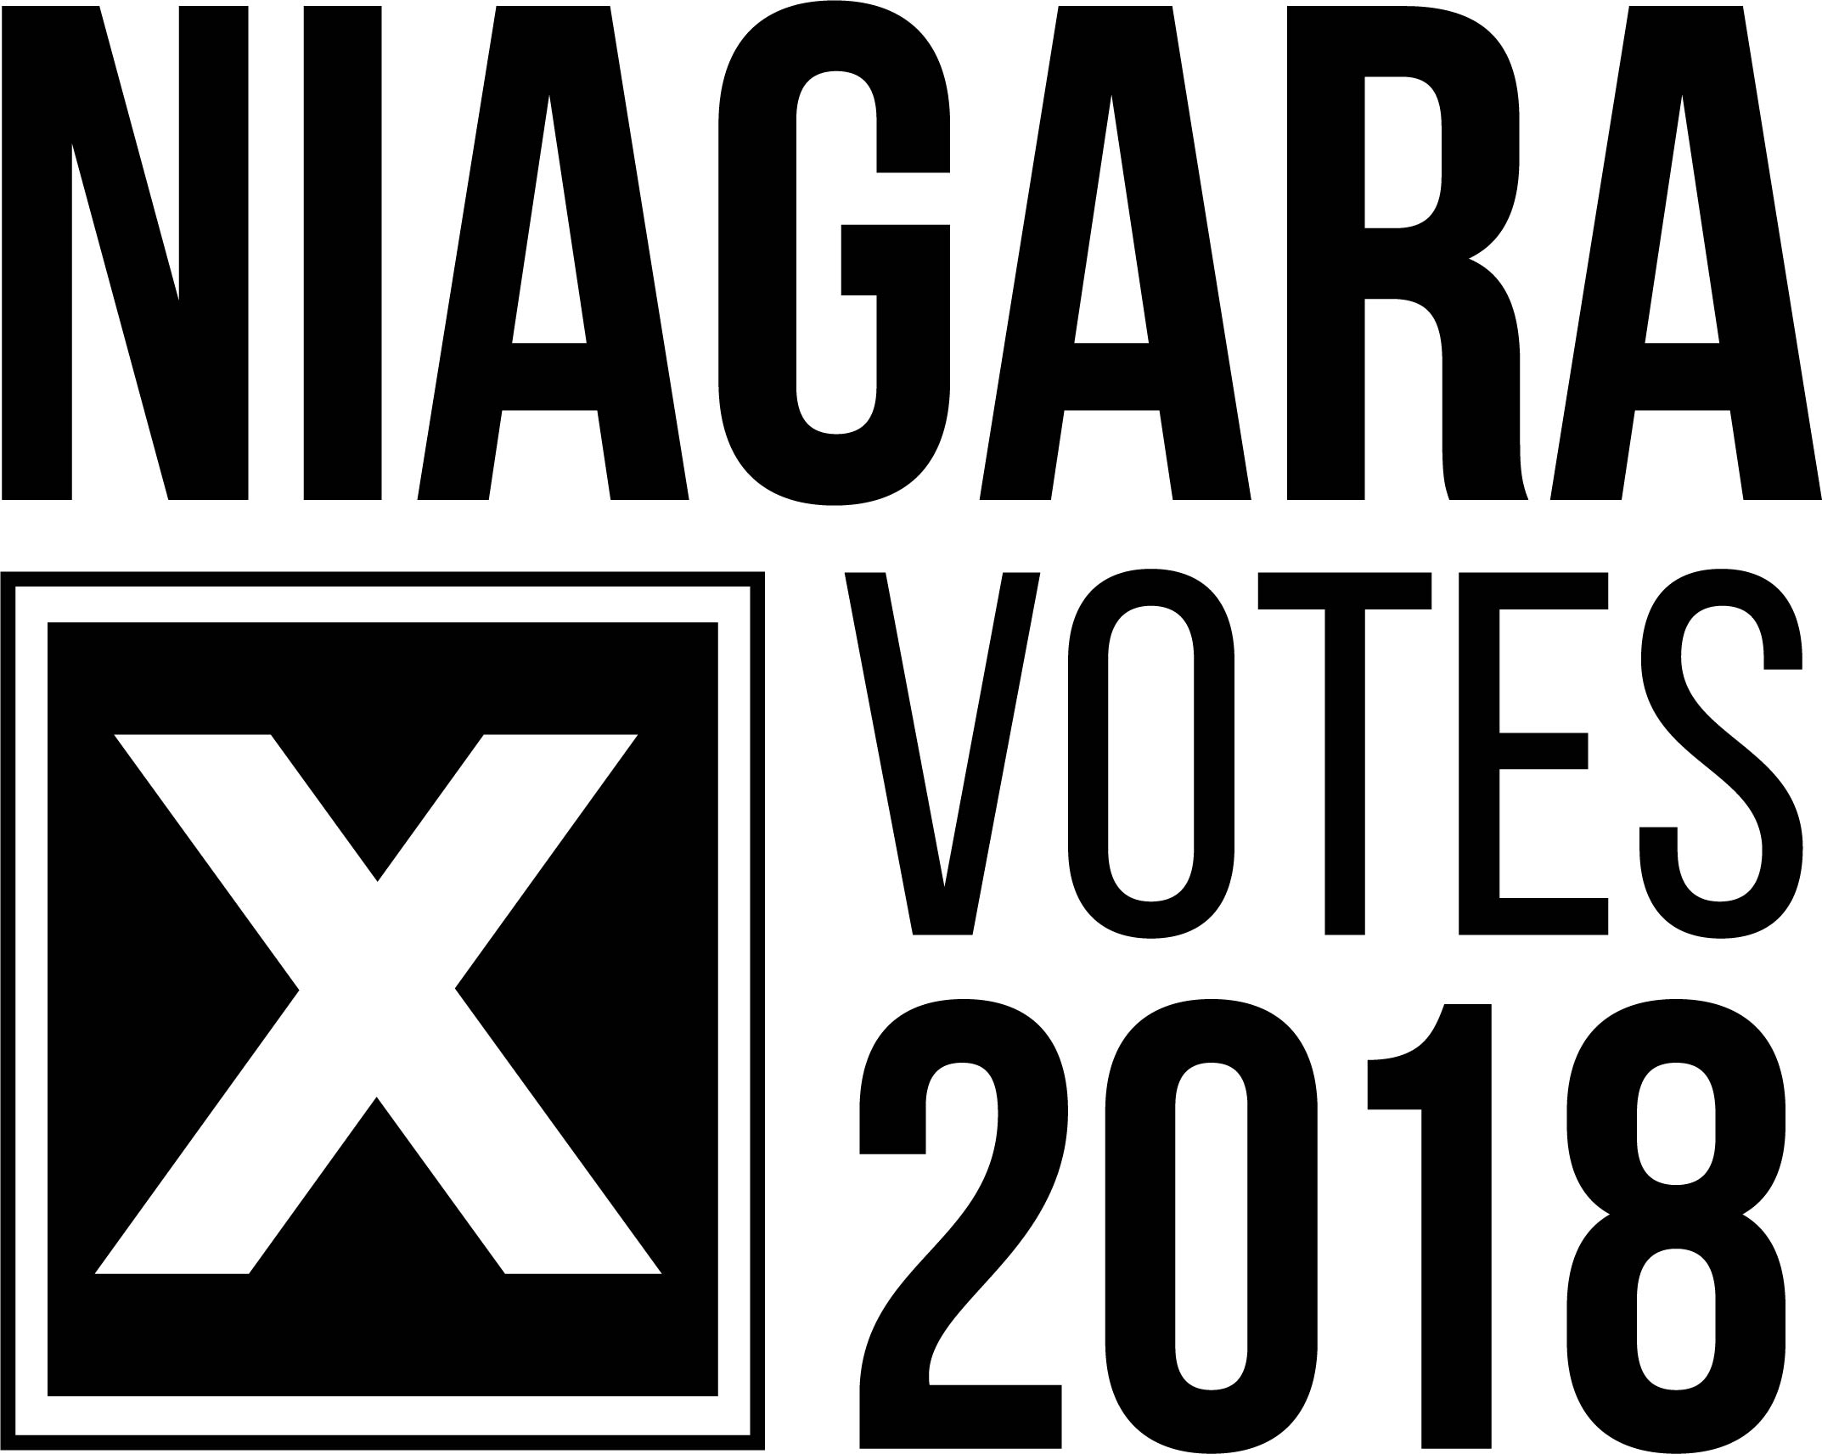2018 MUNICIAPL & SCHOOL BOARD ELECTIONS

Niagara voters encouraged to check voters’ list
July 09, 2018 – With just over 100 days until the 2018 Municipal and School Board Elections, voters are encouraged to visit www.voterlookup.ca to ensure they are on the voters’ list and their information appears correctly.

By visiting www.voterlookup.ca individuals can verify that their name, address and school support information is correct on the voters’ list. Those without Internet access are encouraged to phone the Office of the City/Town Clerk for their local municipality to obtain further information.

Depending on each municipality’s voting procedures, the information will be used to send voters either a voter notification card, a mail-in ballot or deliver details on Internet voting.

“Anyone who has changed addresses moved into Ontario or changed their name since the last municipal election is strongly encouraged to check the voters’ list,” said Carolyn Kett, Acting Deputy Clerk for Niagara Region. “This will result in a quicker seamless voting experience.”

Ontario’s municipal and school board elections take place Oct. 22. In order to vote in the upcoming elections, individuals must be 18 years of age or older, a Canadian citizen and a resident, tenant or owner of land in an Ontario municipality.

Visit www.niagaravotes.ca or contact your local municipal Clerk’s office to learn more about voting requirements.

About Niagara Votes 2018: Election staffs from the Region and all 12 Local Area Municipalities have partnered to streamline communications. This partnership is the first of its kind, designed to ensure candidates and electors across Niagara are aware of key dates and information for the 2018 Municipal and School Board Elections.

For more information, contact:
Melissa Marshall
Communications Advisor
Town of Fort Erie
905.871.1600 ext. 2217 or mmarshall@forterie.ca

